**Project Scope – Data Feed Processing & Validation Automation**

**Executive Summary**

This project focuses on the design, automation, and validation of data feeds using SQL. The scope included generating random input data across three feeds (Feed-1, Feed-2, and Feed-3), detecting and removing duplicates, and comparing datasets to ensure consistency and integrity. The effort was complemented by a structured testing framework (manual and automated) and full documentation of the process.

The solution was executed in multiple stages:

1. Feed Generation: Automated creation of parameterized feeds with configurable row counts and column structures.
2. Duplicate Management: Identification of duplicate records, extraction into a separate output file for audit purposes, and cleansing to retain only unique rows.
3. Data Comparison: Direct comparison of Feed-2 and Feed-3 against Feed-1 to identify mismatches and gaps.
4. Validation: Comprehensive SQL queries ensured zero residual duplicates and correct feed alignment.
5. Testing: A detailed test plan was prepared with end-to-end scenarios, ranging from functional validation to data integrity checks. Automation was introduced to execute tests and improve repeatability.
6. Documentation: The entire process, including objectives, SQL scripts, test results, and automation, was compiled into a professional project report with screenshots for traceability.

Through this approach, the project delivered a robust, repeatable, and auditable process for managing data feeds, ensuring clean, consistent, and comparable datasets. This framework not only demonstrates technical accuracy but also establishes a reusable model for future data integration and validation initiatives.

**Req 1: Generate Random Data Input Files**

**Objective:** To create baseline test datasets (Feed-1, Feed-2, Feed-3) with defined rows and columns. These controlled inputs ensure consistency in downstream validation and provide a foundation for repeatable testing.

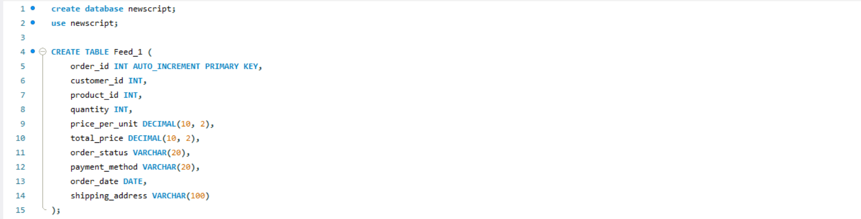

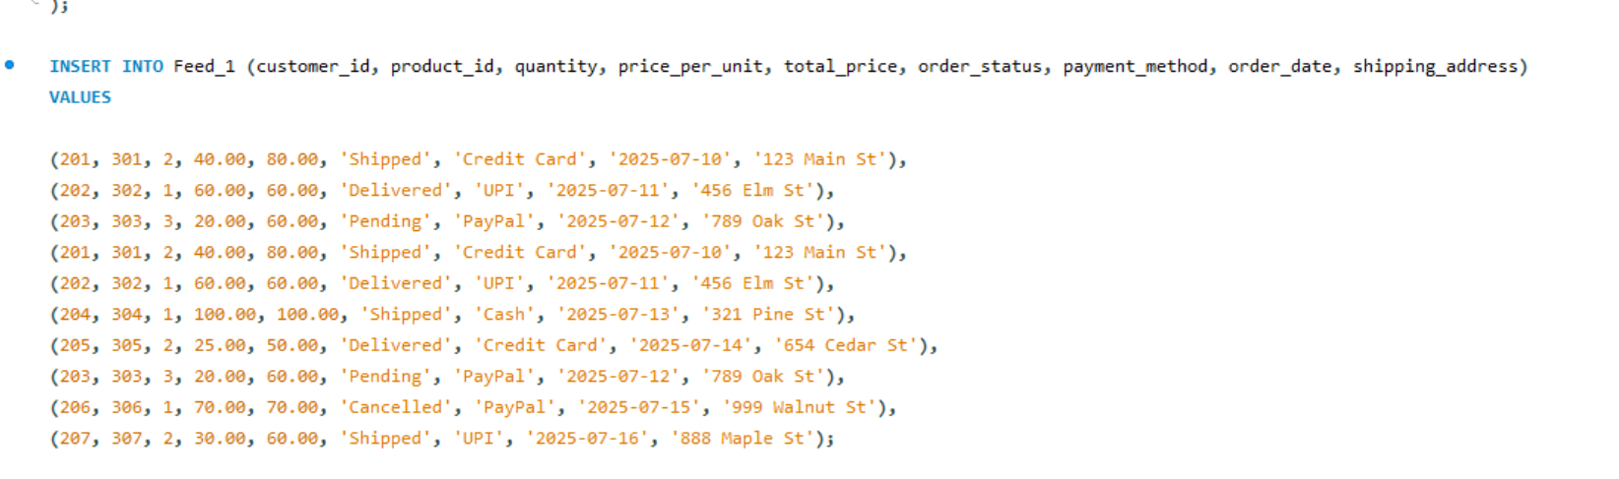

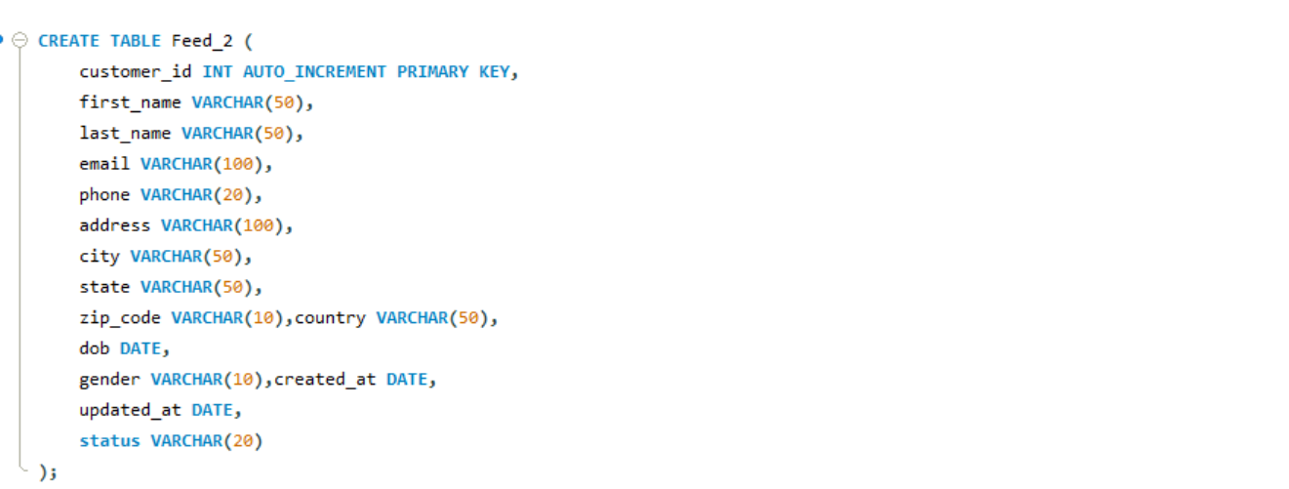

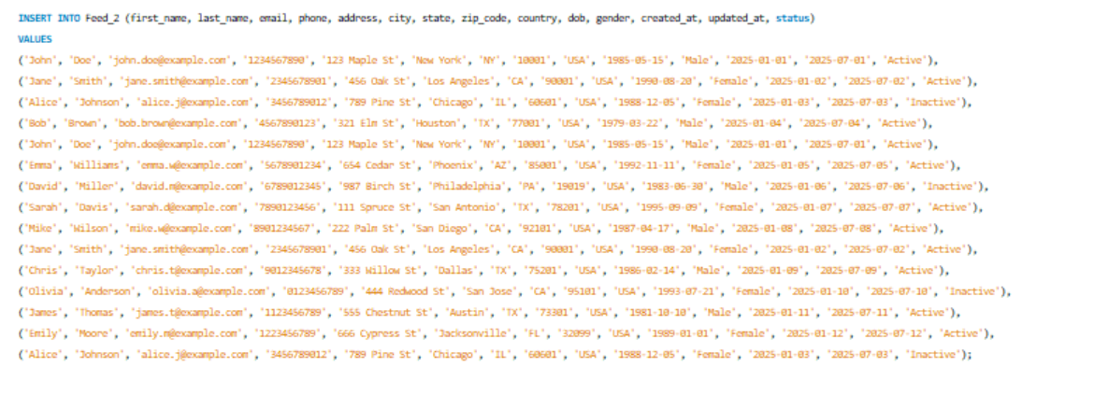

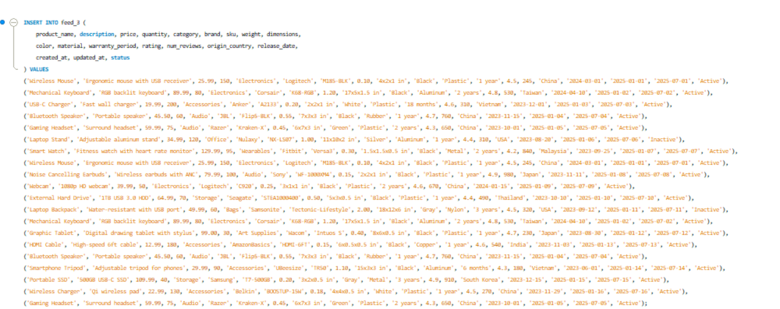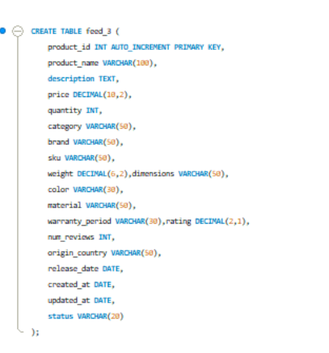

**Req 2: Automate Feed Generation using SQL**

Objective: To develop a parameter-driven SQL procedure that dynamically generates feeds based on user input (feed name and number of rows). This eliminates manual effort, enhances reusability, and ensures scalability for multiple feed configurations.

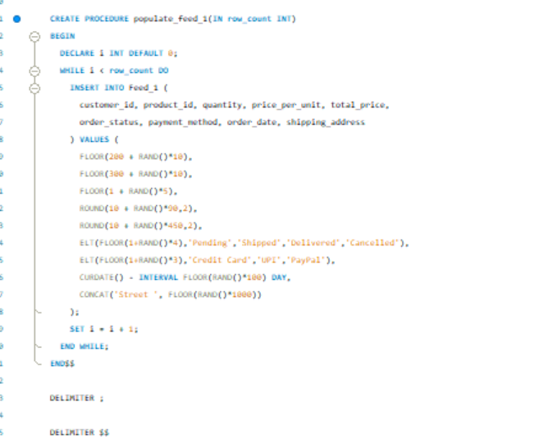

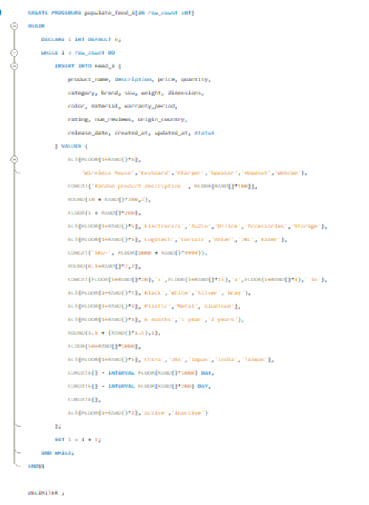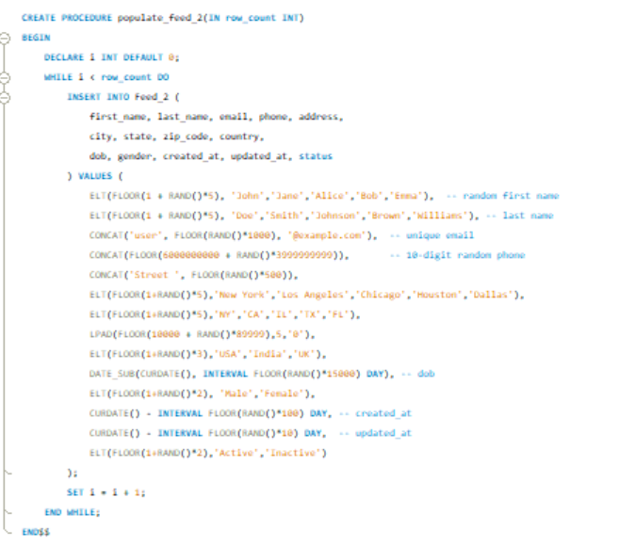

**Req 3: Identify Duplicate Records**

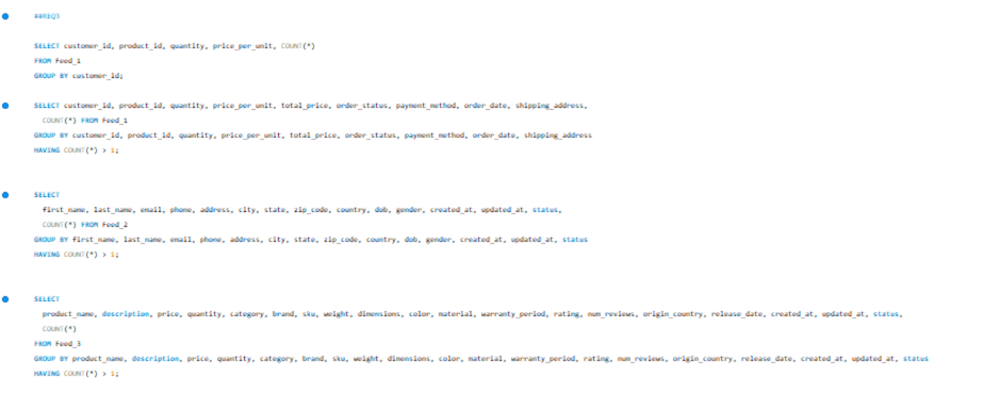Objective: To validate data quality by detecting duplicate rows within each feed. Early identification of duplicates ensures accuracy in reporting and prevents propagation of erroneous data into business processes.

**Req 4: Write Duplicate Records to Output File**

**Objective:** To provide traceability by capturing identified duplicates into a separate “Duplicates” output file. This creates an audit trail for validation teams and supports transparent error reporting.

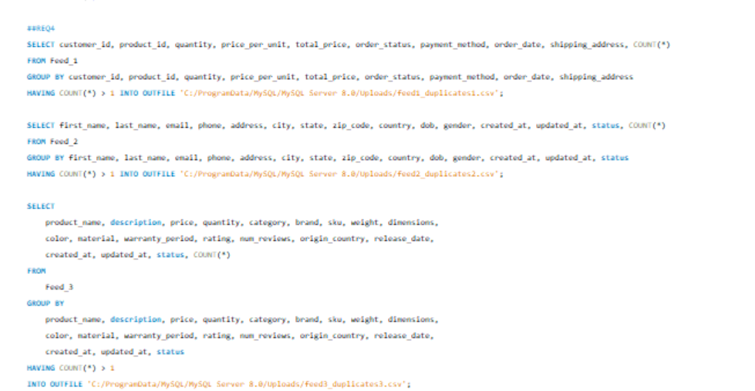

**Req 5: Replace Duplicates with Unique Rows**

**Objective:** To cleanse each feed by eliminating duplicates and retaining only unique rows. This guarantees data integrity and ensures the feed is reliable for further use or comparison.

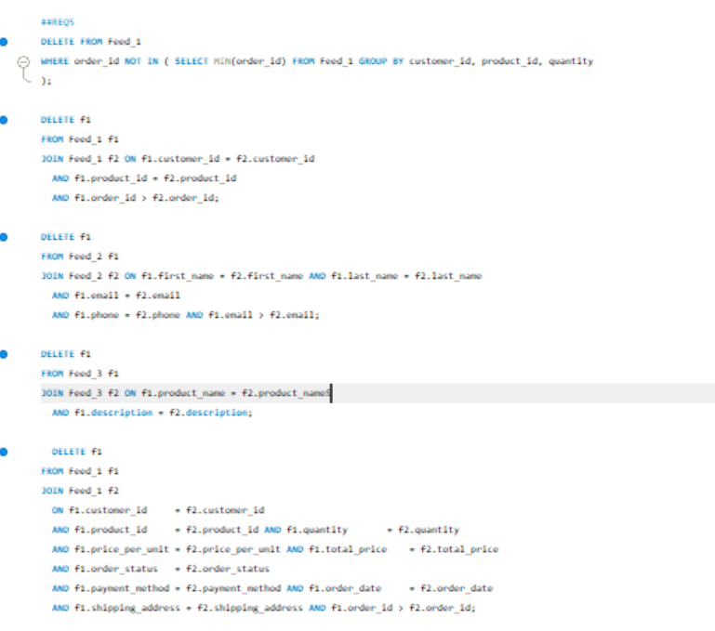

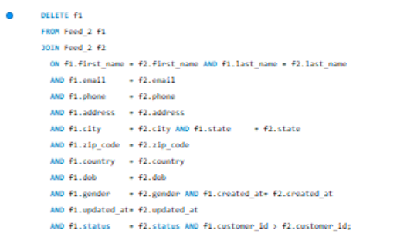

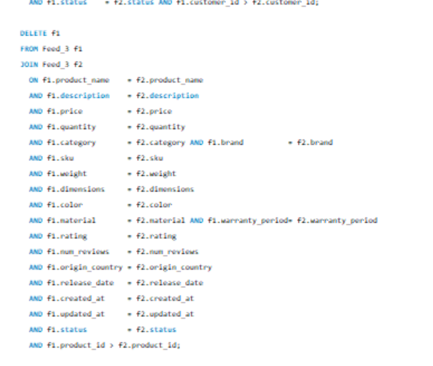

**Req 6: Execute Script and Verify Zero Duplicates**

**Objective:** To validate the effectiveness of the deduplication process. The script should confirm that no duplicate records remain, proving the cleansing step has succeeded.

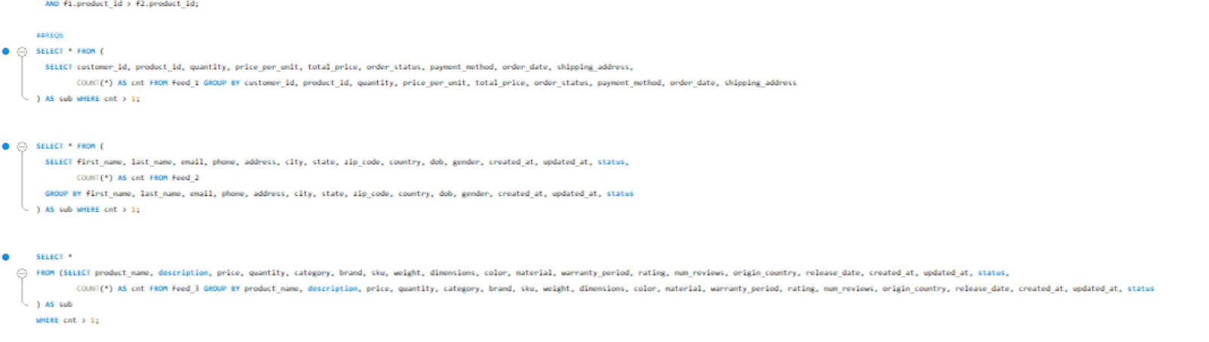

**Req 7: Compare Feed-2 and Feed-3 with Feed-1**

**Objective:** To assess data consistency and alignment across feeds by identifying mismatches and variances. This comparison provides insights into feed integrity and highlights data gaps.

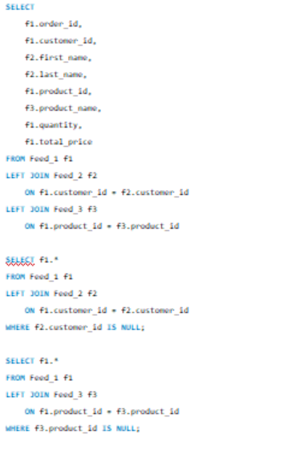

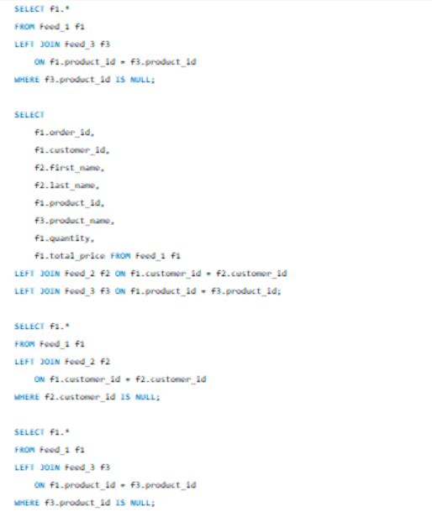

**Req 8: Create Test Plan (Manual)**

**Objective:** To ensure comprehensive functional validation by preparing structured test cases. The plan defines objectives, test steps, and expected results to systematically validate end-to-end functionality.

**Req 9: Automate Test Cases**

**Objective:** To increase efficiency and reliability in testing by implementing automation (via SQL testing frameworks or external scripting). Automated testing reduces manual effort, ensures repeatability, and supports continuous validation.

